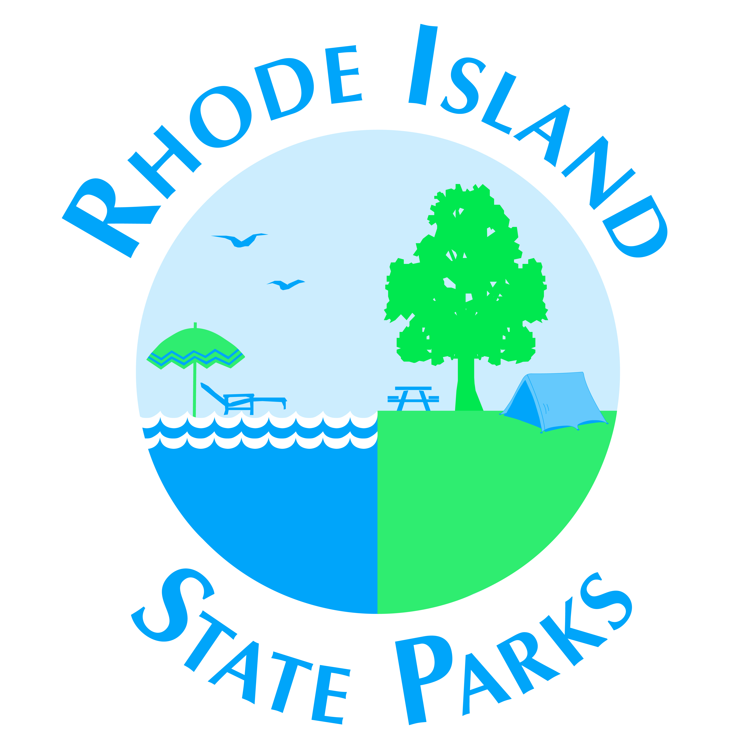
RHODE ISLAND
DEPARTMENT OF ENVIRONMENTAL MANAGEMENT

Division of Parks & Recreation Office 401-667-6200
1100 Tower Hill Road Fax 401-667-3995
North Kingstown, RI 02852 Website www.riparks.com
COVID-19 REQUIREMENTS
Due to the ongoing concern regarding COVID-19 and current executive orders, regulations and guidelines, in addition to the conditions already outlined and agreed to in your Special Use Permit, the Rhode Island Department of Environmental Management (RIDEM) is requiring all Special Use Permit applicants to acknowledge and agree to the following additional requirements:
- Social gatherings (e.g. weddings, parties, family reunions, networking events, etc.) are limited in size in accordance with current executive orders and/or Rhode Island Department of Health (RIDOH) regulations as follows (check applicable category):
  - Indoor event 25 people
  - Indoor events with a licensed catering service (which provides a sit-down meal similar to a restaurant) 50 people
  - Outdoor event 50 people
  - Outdoor event with a licensed catering service (which provides a sit-down meal similar to a restaurant) 100 people
- Public gatherings (e.g. performances, festivals, etc.) are limited in size in accordance with current executive orders and/or RIDOH regulations as follows (check applicable category):
  - Indoor event 125 or 66% of capacity
  - Outdoor event 250
  - Requires a COVID-19 Control Plan (a template is available here)
  - COVID-19 screening of attendees in accordance with current executive orders and RIDOH regulations is required
  - Cleaning procedures, including the frequent cleaning/disinfecting of high touch surfaces (railings, handles, restrooms, door knobs etc.) must be in place.
- Any person within the group covered by the Special Use Permit who is currently sick, has been in contact with another person who had COVID-19 within the past two weeks, is subject to quarantine per RIDOH guidelines and executive orders, or who has symptoms of COVID-19 should remain home and isolate.
- Event participants who are not in household groups must be able to comply with the six (6) foot physical distance requirements for the duration of the event or activity. Fourteen (14) feet should be maintained between the group covered by this permit and other groups.
- All persons within the group covered by the Special Use Permit must wear a face covering in accordance with current executive orders, RIDOH regulations, and guidance regarding face coverings found at www.reopeningri.com.
- All persons within the group covered by the Special Use Permit should have access to soap and water or hand sanitizer that contains at least 60% alcohol.
- The permit holder should retain a record of contact information for attendees for at least thirty days for contract tracing should someone in the group be determined COVID-19 positive.
Conditions Accepted by Applicant:
I understand that checking the boxes above and affixing my signature below, I acknowledge and confirm the above conditions.

Signature of applicant: _________________________________________ Date:_______________________

Print Name: __________________________________________________

Event Name or Organization:_________________________________________________________________________

DOCUMENT DATED: 7/10/20

